Setting up Press Row Monitor output from DakStats /DSTI software

Press Row Monitors (PRM) are a simple box score style view of the game statistics that update every three seconds. They are meant to be used by in-stadium media (TV, radio, newspaper, PA) to show up to date statistics with every play entered in DakStats.

The PRM feature is similar to a webcast, but updates much faster and is less graphical and easier to read.

DSTI can be setup to create an HTML file that is used as a Press Row Monitor. This displays live stats on a local network of computers for press and announcers.

Requirements
- DakStats Football, Basketball, or Volleyball
- Daktronics Scoring and Timing Interface (DSTI) with DSI configuration file

Setting Up DSTI
Install DSTI on your DakStats computer.
If DSTI is not installed, it can be downloaded and installed from dakfiles.daktronics.com. If downloading, you will also need to contact support@daktronics.com for a blank DSTI Configuration file.

DSTI Download instructions

Go to dakfiles.daktronics.com

Click Sports Products

Click DSTI

Download and install DSTIInstall.exe

- Open DakStats
- Click Configure and select Auto Start Interface. (Figure 1) (If new DSI file…copy to Program Files(x86)\Daktronics\DSTI directory)
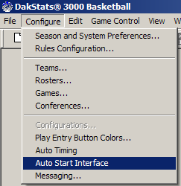
Figure 1: Auto Start Interface

- Open a game. DSTI will start minimized automatically. (Figure 2)
Figure 2: DSTI on the Task Bar

- Open and maximize DSTI.
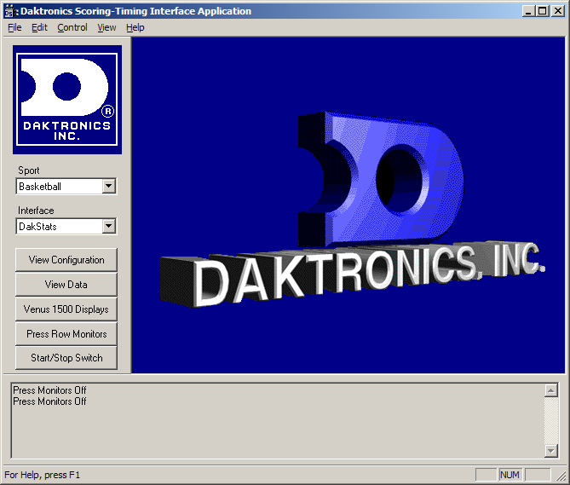
Figure 3: DSTI
- Make sure the proper Sport and Interface is selected. (Ex: Sport: Basketball, Interface: DakStats)

- Click the Press Monitor button on the left.
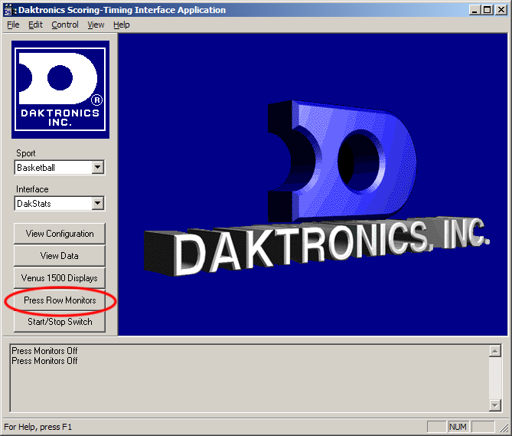
Figure 4: DSTI Press Monitors

- Click Add
- Enter a Name (Figure 6)
- Set Port Type to FILE. (Figure 6)
- Set Out Path to the location where you want to save the press monitor file. Be sure to provide a file name with and HTML extension. Ex: c:\temp\prmon.html

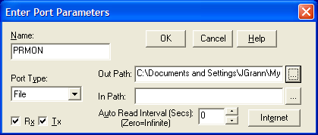
Figure 5: Press Monitor Setup
- Click OK.
- Select change the Send Protocol to HTML. Click OK on the Press Monitor Output. (Figure 7)

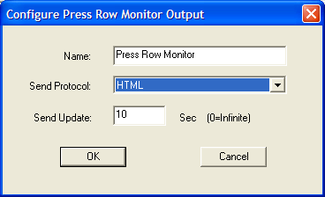
Figure 6: Press Monitor Output
- Put a check in the Press Monitors On check box.

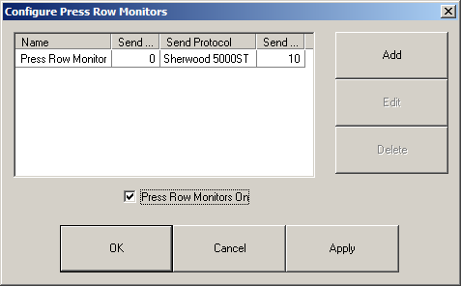
Figure 7: Configure Press Monitors

- Click OK.
- Close DSTI and DakStats (After first time configuration, we need to restart for PRM changes to take effect.)

To view the press monitor, locate the fields you specified in the Out Path and double click it. It will open in your Internet browser.

More Information on Security and Sharing the file:
You can share the HTML file multiple ways. Please discuss with your IT department how best to share based on your school’s IT Security Policies. The two most common ways are listed below:
- Simple Windows File Share. Using the functionality built into Windows, share the folder with Read only rights. To access your file, the members of the media will have to be logged into your network.
  - Right click on the directory where the file is being written in Step 10 above (ex. C:\Temp)
  - Click the ‘Properties’ menu option
  - Click the ‘Sharing’ tab and click Share button
  - Add ‘everyone’ with ‘Read Only’ permissions
  - Then share this path with the people who need to use the Press Row Monitor. An example path would be ‘\\MyComputer\MyPRM\prmon.html’
- IIS Express. DSTI can run a very light version of a Web Server. To access your file, the members of the media will only have to be on your network backbone (not logged in as with the previous file share above)
  - To use this option, in Windows 7 you must run both DakStats and DSTI as Admin (‘Run As Admin’ for properties of both shortcuts). Make this Run As Admin Change before doing any other changes (due to Virtual Space directory).
  - In DSTI: make sure the Control menu option ‘Enable HTTP Server’ is check marked
  - In Step 10 above…the target directory must be pointed at ‘C:\Program Files (x86)\Daktronics\DSTI\website’. You can name the file anything you want, but it must exist in this folder. This folder will become the root virtual folder for our HTTP server.
  - Then share your URL with people who need to use the Press Row Monitor. You can use either Computer name or IP address. Notice there are no subdirectories, simply the Computer and the File.
    - Example using computer name ‘http://MyComputer/prmon.html’
    - Example using IP address ‘http://192.168.1.100/prmon.html’

Other ways to share.
- You can simply have DSTI create the file. Then have the IT department expose the file for the members of the media. They might have several other options such as full blown IIS Server (which can be installed under Add/Remove Programs)
- Another method is via UDP packets to our Press Row Emulator software. The drawback to this is every member of the press will need to install our Press Row Emulator software. There is no IIS setup and you do not have to run as admin. UDP is a Port type that can be set in Step 10 above.
- Game Cast – only available for Football and Basketball. Game Cast is an interactive Press Row Monitor that has much more data available. It is separate application which needs to be purchased, downloaded and installed from the dakfiles.daktronics.com. There is no need for DSTI. DakStats will output this feed directly over UDP.

