Creating a USB drive for offline FL5 update

- Download and run rufus https://rufus.ie/en/
- Select your USB device
- Choose “Non bootable”
- Choose FAT32 or exFAT
- Click START
- 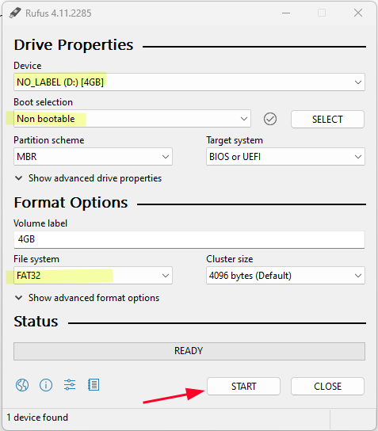
- After the drive has been formatted then place the dakupdate.tar.gz file on the USB drive in the folder the Windows automatically creates for the device
- Eject the drive by right clicking on it in the file explorer and selecting “Eject”
- 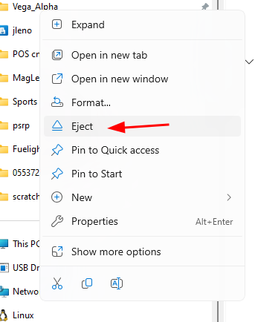
- Remove all USB devices from the FL5 and insert the USB drive
- Navigate to the System Tools page and click “Check for Update” the UI should show that a USB update is available

